# SCHOOL OF COMPUTER SCIENCE AND ENGINEERING DEPARTMENT OF INTELLIGENT SYSTEM

**LOVELY PROFESSIONAL UNIVERSITY, JALANDHAR**

## FORMAT FOR PREPARING END TERM PROJECT REPORT

The purpose of the report is to explain overall working of the project. The report should contain an account of the activity for whole of project and as well as implementation of its working.

1. First Page (Appendix 1)
2. Declaration Page (Appendix 2)
3. Table of Contents (Appendix 3)
4. Bonafide Certificate for Supervisor Signature and Details (Appendix 4)
5. Background and objectives of the project assigned.

An introductory description (2-3 pages) of the project with respect to: Background, motivation and outcome of project and concrete goals and objectives.

1. Description of Project

The students are required to provide description in terms of modules and prepare pictorial flow of project.

1. Description of Work Division in terms of Roles among Students.

Here students are required to explain the work done by each student for roles allotted in MTE report. 8. Implementation of scheduled work of Project

The students are required to provide implementation of project in terms of its working and provide screenshots of designed web pages with proper explanation.

1. Technologies and Framework to be used.

The students are required to mention the technology and platform to be used in project.

1. SWOT Analysis achieved in project.

Include an analysis of project in terms of Strengths, Weaknesses, Opportunities and Threats. Strengths and weaknesses refer to the internal capabilities of the project, i e are under its control, and should be regarded relative to competitors, whereas opportunities and threats are found in the external environment, usually outside the control of the project.

Typing Instructions:

The impression on the typed copies should be black in color. One and a half spacing should be used for typing the text, and shall be typed in the Font style ‘Times New Roman’ and Font size 12, unless otherwise stated explicitly.

## APPENDIX 1

**Art Store**

**END TERM REPORT**

***by***

**Aman Deep, Rishav Kumar, Priyanshu Saxena**

Section: K19TG

Roll Numbers: A-23,A-26,A-32



**Department of Intelligent Systems,**

**School of Computer Science Engineering,**

**Lovely Professional University, Jalandhar**

April, 2020

## APPENDIX 2

**Student Declaration**

This is to declare that this report has been written by me/us. No part of the report is copied from other sources. All information included from other sources have been duly acknowledged. I/We aver that if any part of the report is found to be copied, I/we are shall take full responsibility for it.

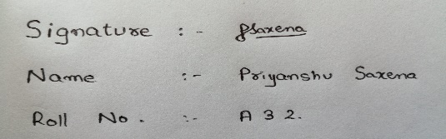

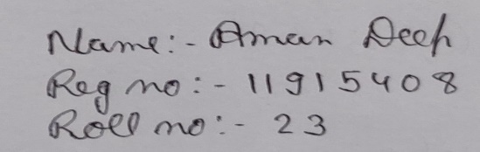

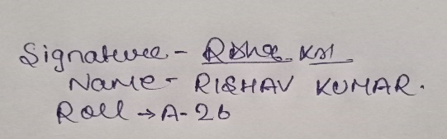

Place: Kota, Rajasthan

Date: 12 April 2020.

**APPENDIX 3**

**TABLE OF CONTENTS**

**TITLE PAGE NO.**

|  |  |
| --- | --- |
| **1. Background and objectives of project assigned ................** | **1** |
| **1.1** ........................................................................................ | 1 |
| **1.1.1 ....................................................................................** | **3** |
| **1.1.2 .....................................................................................** | **5** |
| **1.2 .........................................................................................** | 7 |
| **1.2.1 .....................................................................................** | **7** |
| **1.2.2 .....................................................................................** | **9** |
| **1.2.3 .....................................................................................** | **10** |
| **2 Description of Project ... ........................................................** | **14** |
| **2.1 ..........................................................................................** | **17** |
| **2.2 ..........................................................................................** | **18** |

APPENDIX 4

BONAFIDE CERTIFICATE

Certified that this project report “ART STORE” is the bonafide work of “PRIYANSHU SAXENA, RISHAV, AMAN DEEP” who carried out the project work under my supervision.

### <<Signature of the Supervisor>>

<<Name of supervisor>>

<<Academic Designation>>

<<ID of Supervisor>>

<<Department of Supervisor>>

Background And Objectives of the Project Art Store

The project allotted to our group is Art Store, which basically works as a website trying to represent and sell some of the famous and most prestigious art work done by some of the best artists around the world, be it of the old 19th century or the newest 21st century artists.

The basic motive of this website is to represent the art works done by great artists, to sell them, and to make this website more user friendly, this website contains all the types of details/contact info or any other information which is related to either buying/selling of the drawings, and so the user will not have to wander here and there for any enquiry.

This website contains numerous pages namely:

1. Firstly, the Home Page itself.
2. Then comes the Login Page.
3. After it comes the Art(s) Page.
4. Then comes the Artists Page.
5. One page is related to the Ratings.
6. Another one is the Contact-us Page.
7. Privacy Policy.
8. Auctions.
9. Last but not the least the Blog page.

The basic structure of all this webpage consists of table included with both internal and external css, some of the webpages include internal and external bootstrap, which may require internet connection to show their properties and uses.

The idea was taken from the example given to us in the project manual, but not as a whole, more changes were made to the project like:

1. The whole nav-bar was shifted to the left-hand side of the home web-page, while in the project manual it was given at the top of the webpage.
2. The project manual had the pics shown like Instagram, but in the home-page we just kept the top 5 pics, with their prices included, and the rest of the pics can be seen in the Art(s) web link, which has many more categories.
3. There was no name of the Art-Store, which would have led to an unrealistic project work, hence ARP name has been given to the store, where A is standing for Aman Deep, R is standing for Rishav and P stands for Priyanshu, all the three members who have created this whole design of the website.
4. The arts/paintings have not been divided into the section like featured/most liked, but it has been processed like:
5. Nature related Pictures
6. Comic Drawings
7. Drawings by Artists
8. Paintings Done by Artists.

This will lead the user/customer to view the items related to his/her choice, but not with the choice of others, and that is why the sections like this have been made, which will also help the customer to comfortably select his/her choice.

1. In the project manual, their was a dropdown part of the form related to the Artists, which could have led to the confusion to the customer to view the type of Artists, hence a change is made in that section also, which consists of a whole page related to Artists and some of their Information, which will help user to select the type of drawings/paintings on the basis of his/her favorite artist.

Description of Project

The project allotted to us is the Art store. This is a place where any individual can find his/her necessary drawings/paintings done by some of the best painters and artists around the world.

The user can start his/her roaming in the art store by just clicking on the first/main home-page of the website, which is directly linked to the other webpages.

The main home page is linked with the following webpages:

1. Login
2. Home
3. Art(s)
4. Artists
5. Internships
6. Auctions
7. Contact-us
8. Privacy Policy.

Below are the description of the webpage with their respective screenshots and explanation with working.

Home Page

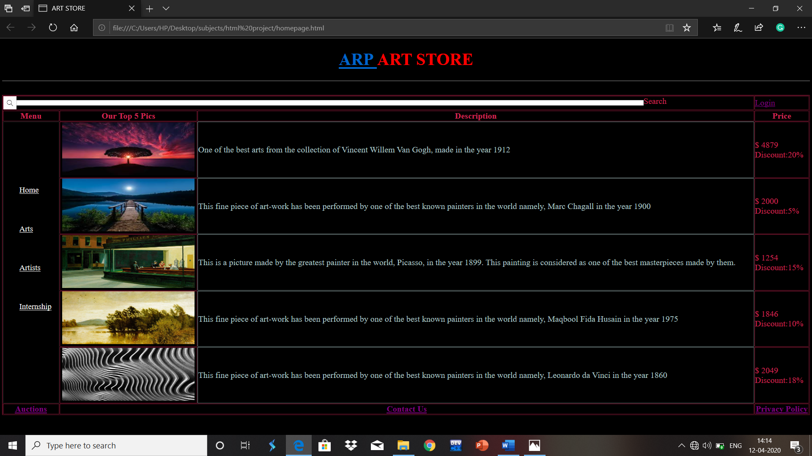

The above webpage is of the home page, given a background texture of black color, the table design with a stylish light red color which makes a perfect color combination for the starting page.

As seen above, the header part of the Home webpage consists of the name ARP Art Store, where A stands for Aman Deep, R stands for Rishav and P here stands for Priyanshu, the three individuals who have supported each other to design this website.

The ARP is not just a name of the art store, but is also another link, which is made to show about the owners of this website, about the information of all the three individuals.

Below the name of ARP, there is a line, separating the header part from the body part, colored white, so as to make a simplified look.

Below the header part, it starts with the body, consisting of a table, in which the top part is having only 2 columns, comprising of the search part and other one the Login part.

The search part is made by using the search image, and the form, which gives the user to search anything on the webpage.

The Login part is another webpage which allows the user to give his/her information, if he/she wants to make any purchase, or want to sell any item.

Below the search part, we are having the Menu part, which is made by using rowspan, for 5 rows, which consists of several other webpages including:

1. Home
2. Art(s)
3. Artists
4. Internship
5. Ratings

The center part of the table consists of the top 5 pics, which are rated the most, which is accompanied by their description, who made these paintings and in which year.

Description is written in light blue color, so as to show it different from the other contents of the table.

On the rightmost side of the table, a column has been fixed for the price section, showing up the prices of the top 5 pics respectively, and with their respective discounts, which can be applied if a customer wants to buy one of those.

Login Page

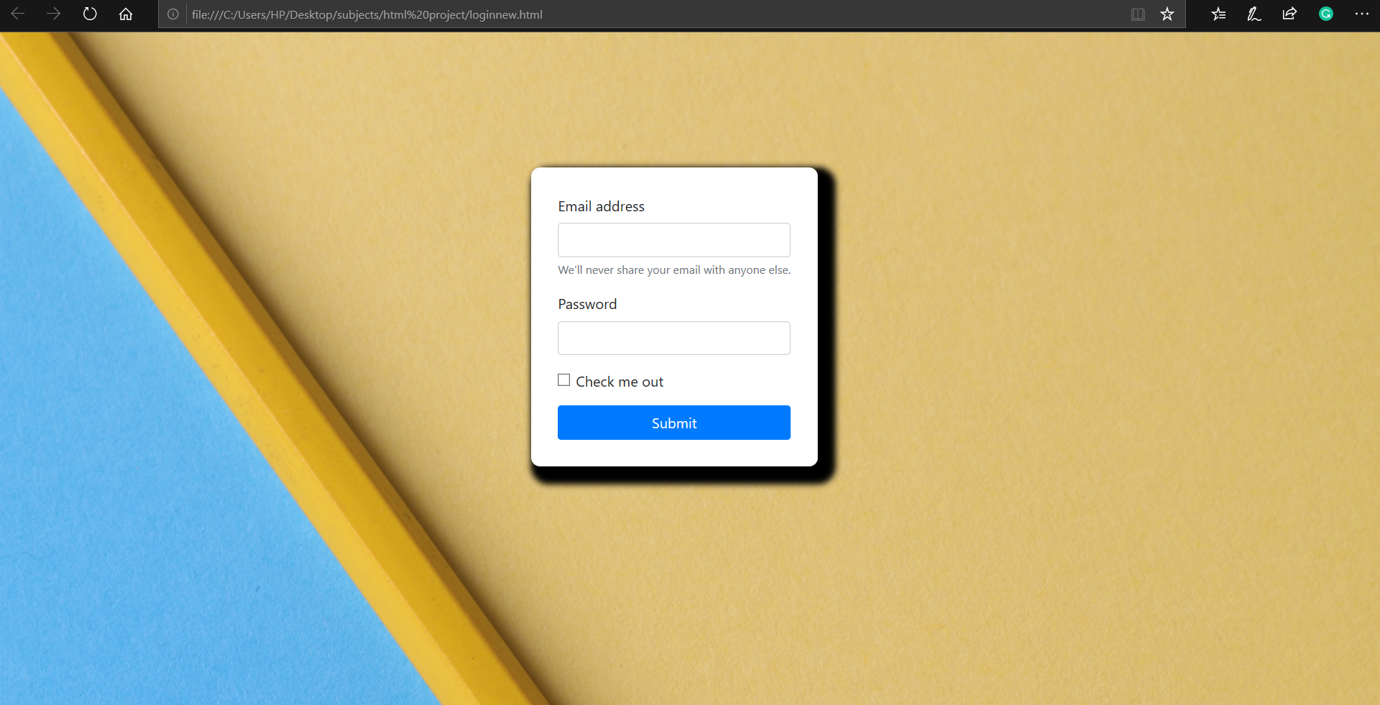

This is the login webpage, which is mentioned below the header and on the rightmost side at the starting of the table in the Home webpage.

This webpage is made responsive, i.e., it can be used as both as window viewing as well as mobile viewing, which gives it an attracting look towards the customer.

This creativity has been done with the help of online bootstrap and css, which has given it a far better look than a normal webpage.

This webpage requires internet to be accessed, as it contains online bootstrap 4, and which can only be run with the help of some connectivity of internet.

This is made responsive with the help of the class container fluid, and for the shadowing effect, the css has been applied in the form of the file global.css.

The background image is chosen in such a manner, that one can see the responsive effect easily.

Art(s) Webpage

This is the webpage which contains the further division of the images/drawings/paintings, as per the requirement of the customer/user.

One of the contents of the website is shown below:

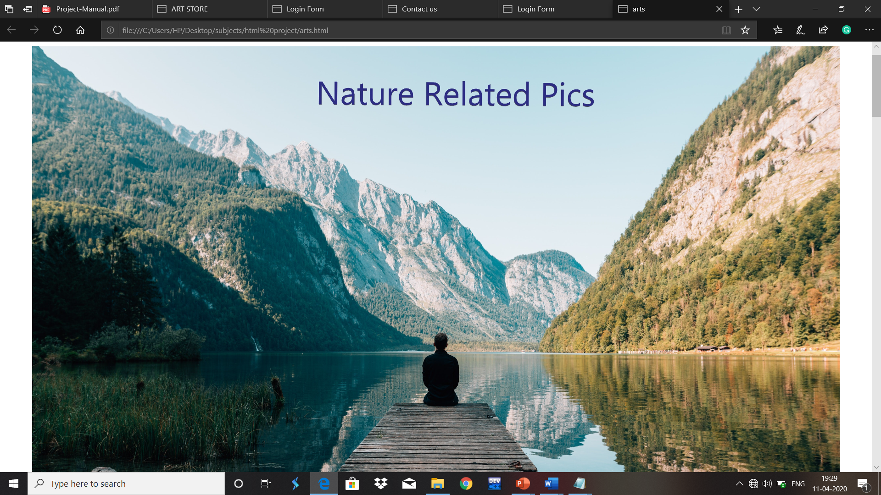

The webpage is further divided into next divisions namely:

1. Nature Related Pictures: Not every time one needs a painting and drawings of artists, some have different tastes, hence this part is made for the nature lovers, pictures related to nature, and some form of good photography.
2. Comic Related Pictures: The one who loves cartoon/fictional character drawings, can get on to this website, it is completely meant for them, containing the world-famous artists characters and drawings.
3. Drawings: This is the section where one can go to see the drawings done by artists, without giving them any special effect of coloring, only shading and sketching is there.
4. Paintings: This is the last section, where you can find the painted and finished drawings, colored with beautiful colors, done by the great artists.

Artist(s)

This is the webpage where one can find the history about the paintings and their artists itself, this webpage is meant to show all about the artists, who have got their paintings in this Art store.

Below is the snapshot shown of the webpage:

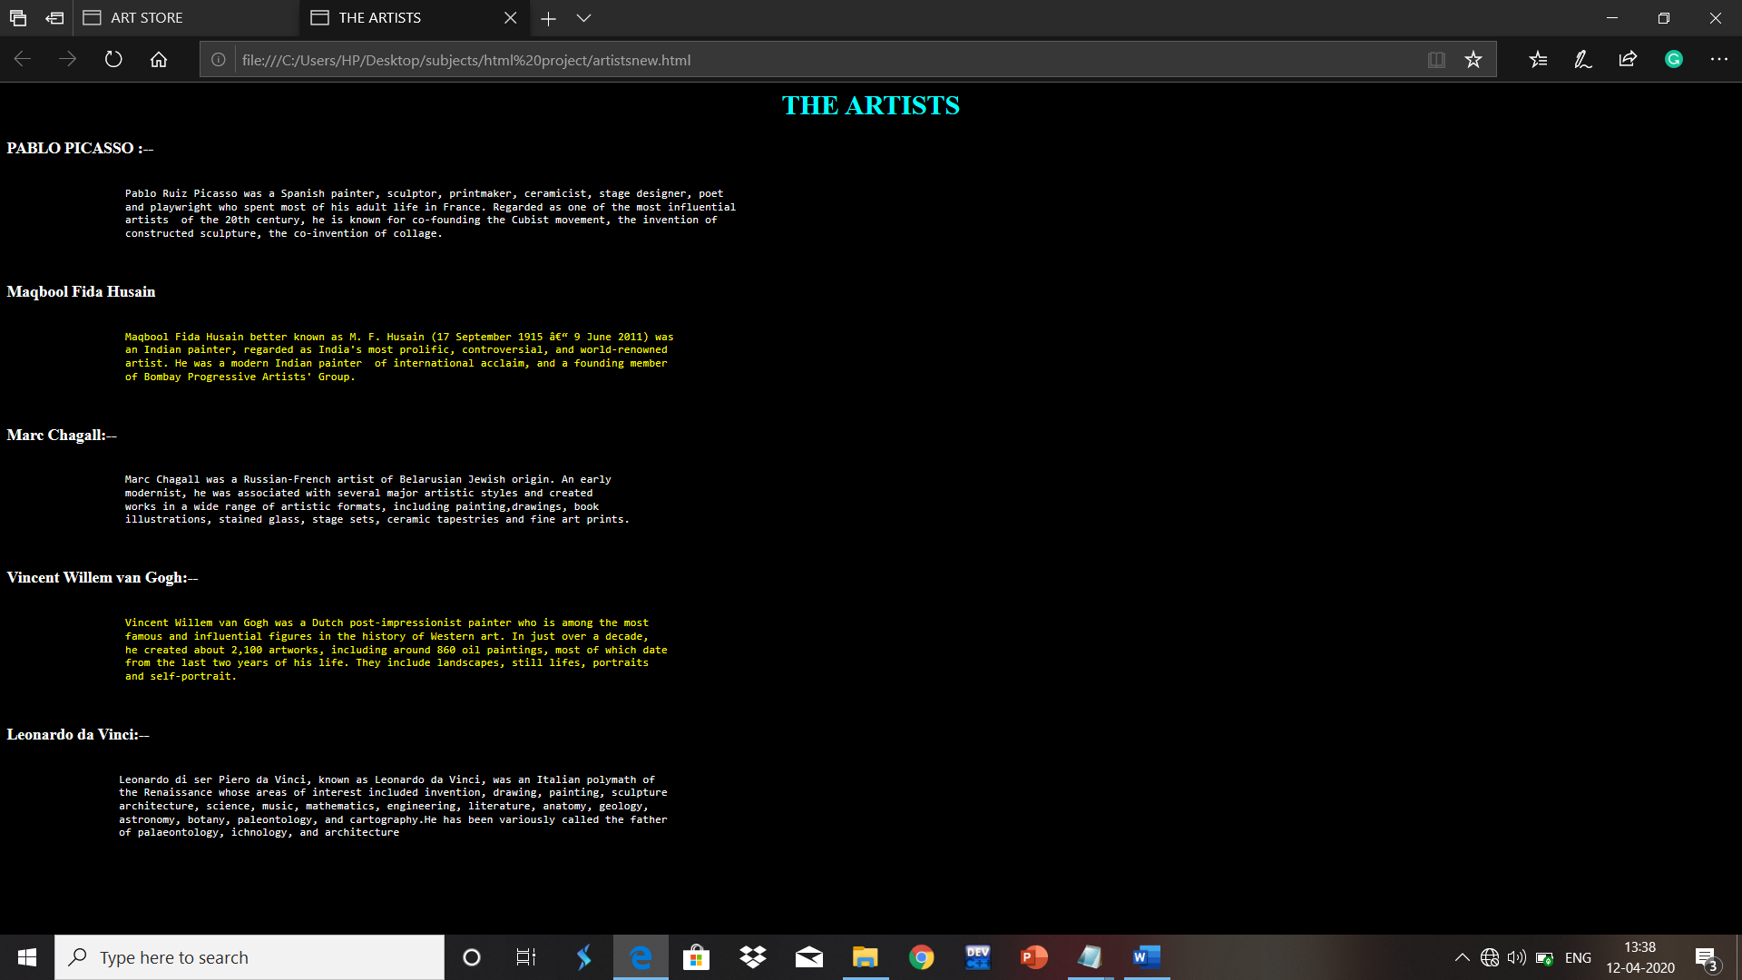

Auctions

This is a website which allows the customer to view the places where the auctions are held, this website contains the contact info of the headquarters where the auctions are held, with a proper info of the address and the email-id.

This website has been made with the help of simple use of html, containing a table with 3 columns and multiple rows, to add more gesture, the cell padding and cell spacing has been used.

To make the table more beautiful, a good combination of colors has been chosen, where the background color is more towards greyish type and the table with the written content has been colored with more towards pinkish type, giving it a good look.

Special Conditions have been written down, showing the terms and conditions for a person before joining /attending any auction, so that user does not face any problem at the destination point.

The snapshot of the website has been shown below:

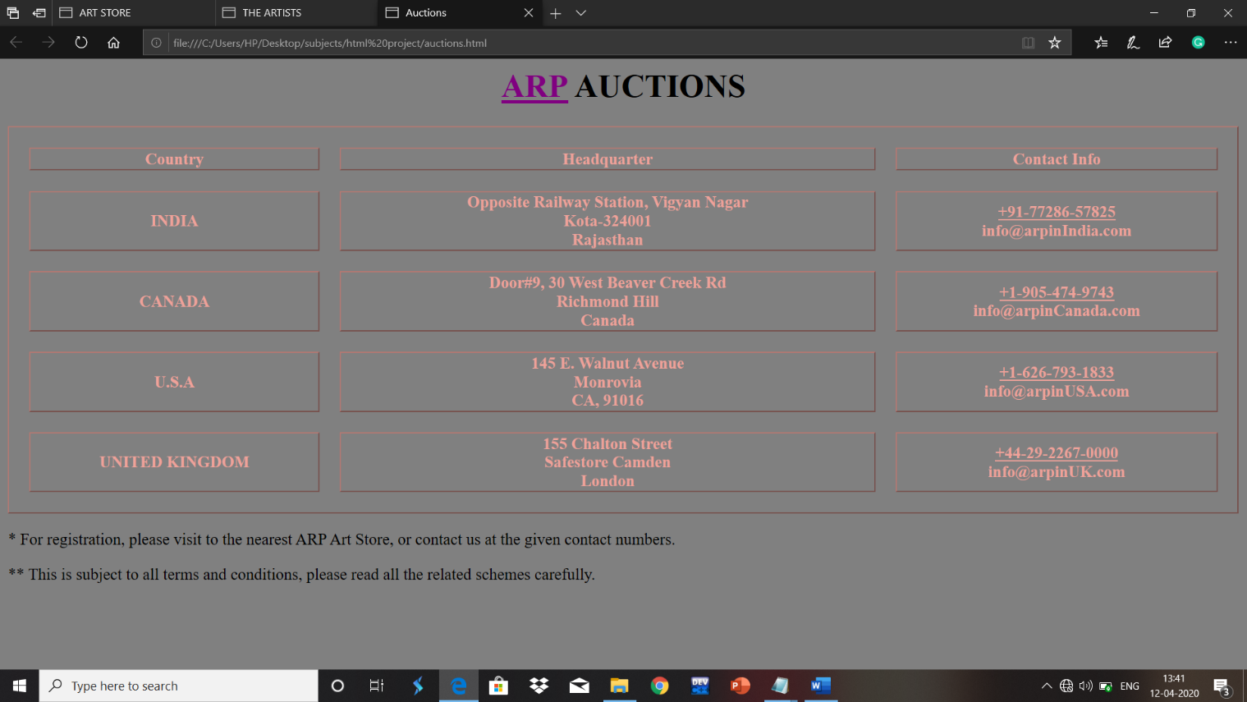

Privacy Policy

One of the most important websites that shows one of the fundamental rights of the person to ask, why we are taking his/her information during any login/sign-up or during any buying/selling time.

This shows that the customer will contain his/her privacy, no matter what will be the conditions, his/her privacy will not be allowed to leak.

The information is being collected for the security purpose of the website, to keep an eye on who is visiting the website, and for what purpose.

What are the information that we collect?

If you are **just browsing the website**, we collect the same basic information that most website collect. We use common internet technologies, such as the cookies and web server logs. This is the stuff we collect from everybody, whether they have an account or not.

The information we collect about all visitors to our website includes the visitor's browser type, language preference, referring site, additional website requested, and the date and time of ach visitor request. We also collect potentially personally-identifying information like **Internet Protocol (IP) Addresses**.

Why do we collect this information?

We collect this information to better understand how our website visitors use ART STORE, and to monitor and protect the security of the website.

Information From User With Accounts

If you **create an account**, we require some basic information at the time of account creation. You will create your own use name and password, and we will ask you for a valid email account. You also have the option to give us more information, if you want to, and this may include "User Personal Information".

"User Personal Information" is any information about one of our users which could, alone or together with other information, personal identify him or her. Information such as a user name and password, an email address, a real name, and a photograph are examples of "User Personal Information".

User Personal Information does not include aggregated, non-personally identifying information. We may use aggregated, non-personally identifying information to operate, improve, and optimise our website and service.

Why Do We Collect This?

1. We need you User Personal Information to create your account, and to provide the services you request
2. We use your User Personal Information, specifically your user name, to identify you on Art Store.
3. We use to fill out your profile and share that profile with other users, if you ask us to.
4. We will use your email address to communicate with you. If you've said that's okay, and only for the reasons you have said that's okay. Please see our section on email communication for more information.

The snapshot of the site is being given below, to give an idea how it looks like:

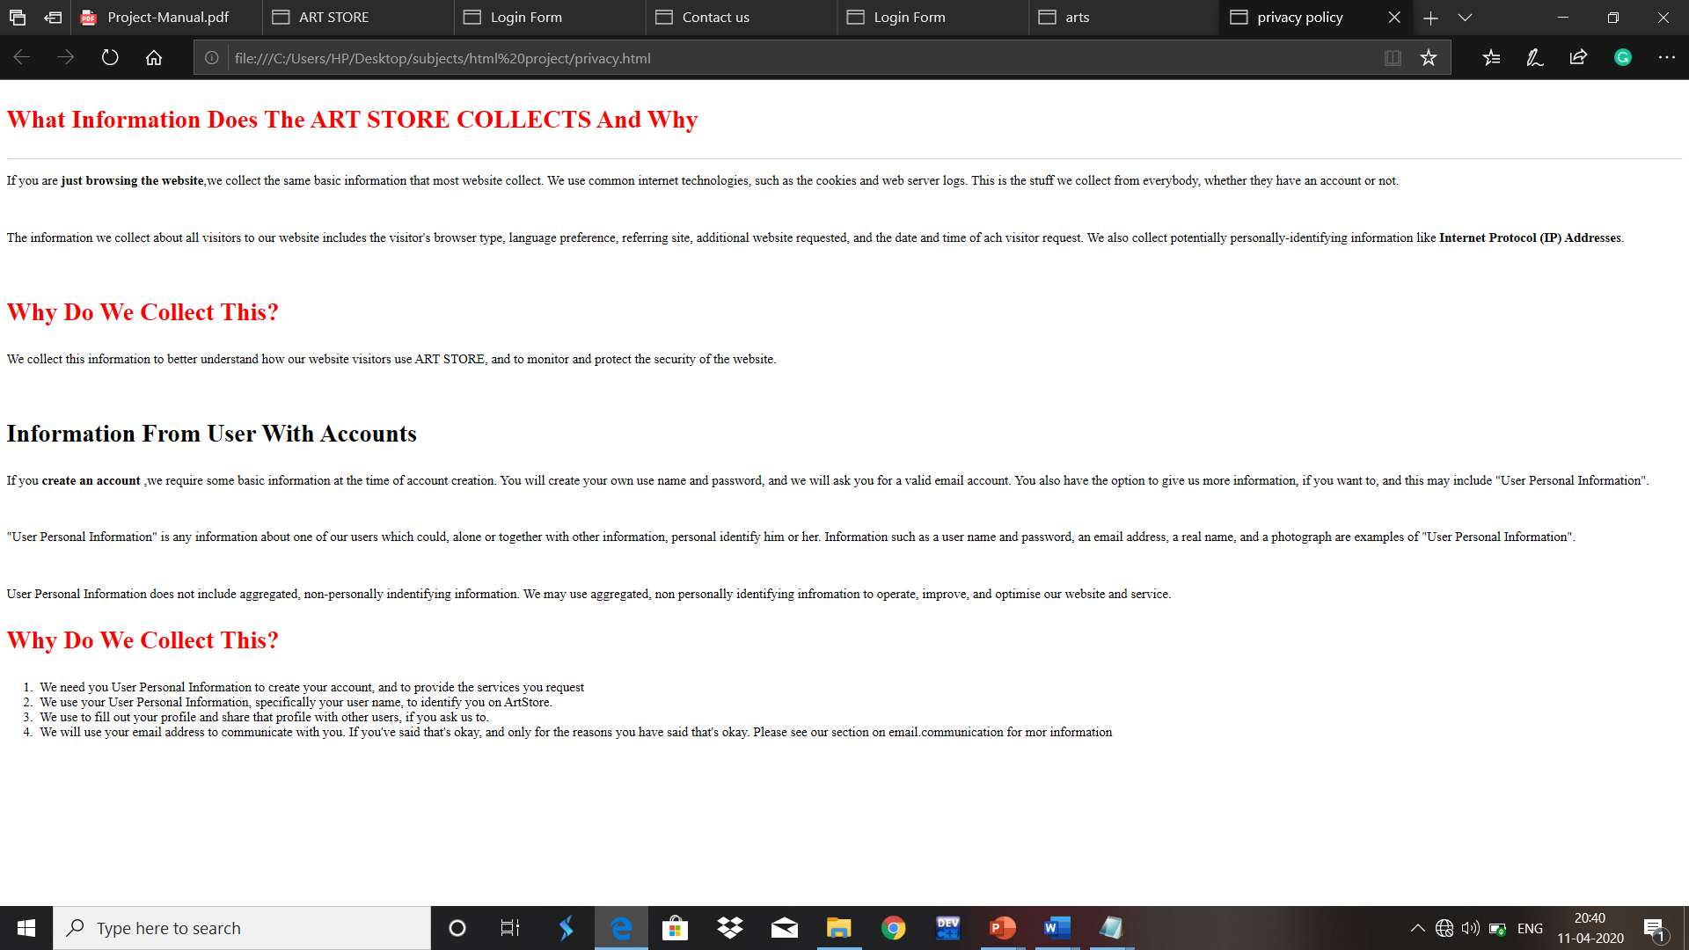

This website has been developed by using the HTML codes, like <br/> and heading parts, and to make this website look more better, the important parts have been bolded with black and the heading parts which a user should read have been coloured with red, to make it sharper.

This website is present in the lowermost part of the Home webpage, besides the contact-us website, which can be easily spotted by the customer.

Contact-Us

This is one of the websites present at the bottom-most part of the Home page.

If the customer is having some doubts regarding anything, like auctions/buying/selling or having some technical issue, then the customer should look out for this website, and here he/she is allowed to give his/her contact info with the type of problem they are having, being typed in the message box, where they will receive their answers related to queries within 24 hours.

The snapshot of this website is given below:

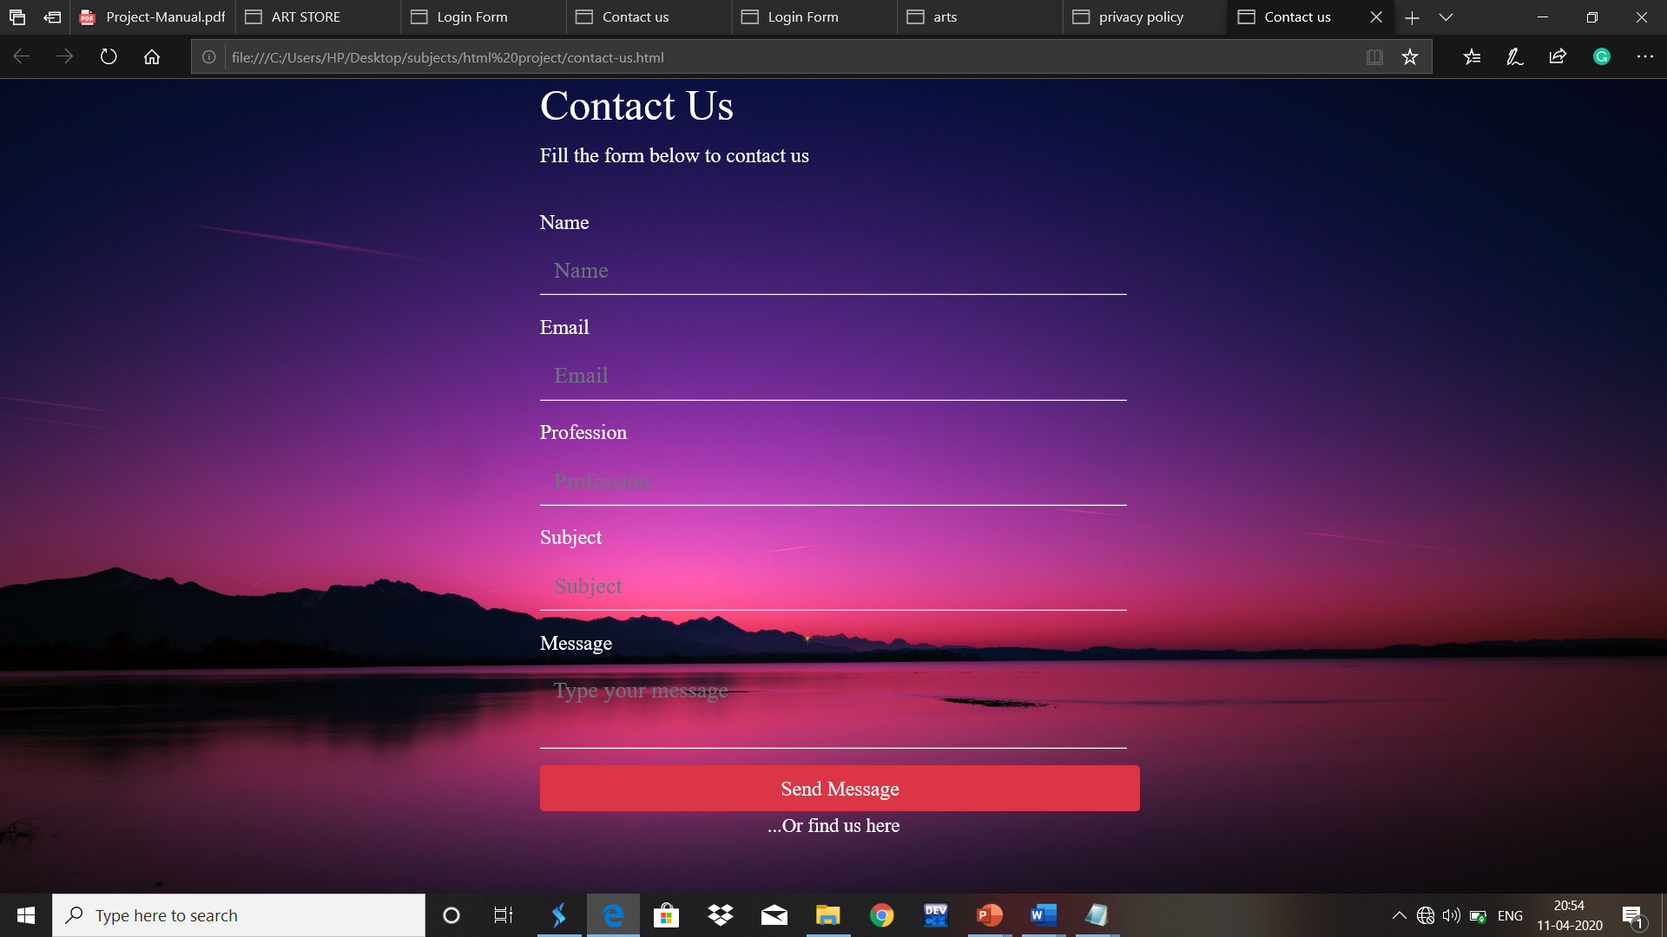

The background has been chosen a little darker, so as the color combination looks perfect.

This website has been totally made out by the use of Bootstrap 4(offline version), which is also responsive, which gives it a good look.

The written contents have been colored with pure white, so as to show the type of form clearly to the customer, and below there is a form which consists the area where the customer is allowed to give the information and the query related to the website.

The Send Message option has been made with the help of the button option, available at the Bootstrap 4, using the Danger color, which allows it to look different from the above given forms.

The user, whenever clicks on one of the forms to fill up the information, a white box will appear, which makes the user more comfortable to write the information in the box, but to represent it in a good way, the forms have been made transparent, which gives a better look to the whole website.

Internship

This is a simple website, which allows the students, who want to do internship at our store, related to software development, website development and many others.

This website has been made by simply using the form part of the HTML, with its properties, such as dropdown form part, and the blanks so that the user can give his/her information regarding the required fields for the internship selection.

The snapshot of the above website is given below:

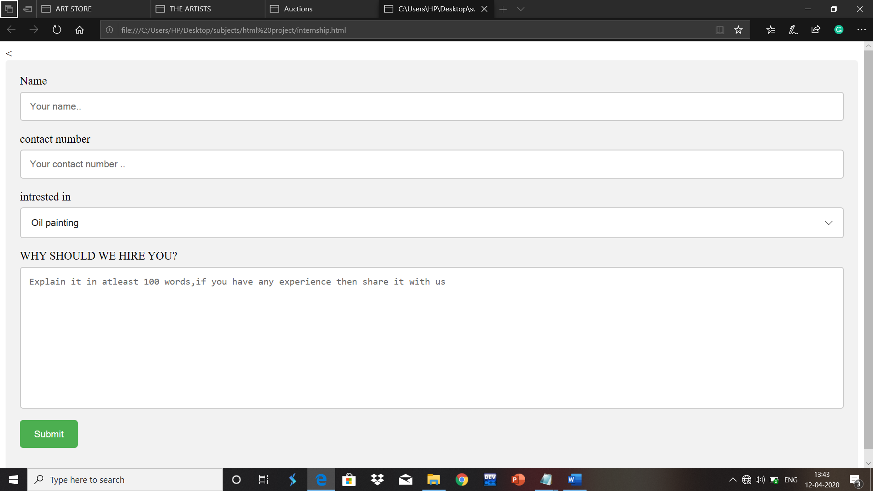

Roles of Students on Websites

1. Priyanshu Saxena: The main webpages like Contact-Us, Home, Auctions, Arts, Login page were created and designed by him, with the help of Bootstrap, CSS, Java-Script and basic HTML.
2. Rishav Kumar: The designing of the webpages like Artists and Privacy Policy has been done by him with the help of basics of HTML.
3. Aman Deep: The designing of the webpage Internship has been done by him with the help of CSS and basic HTML.